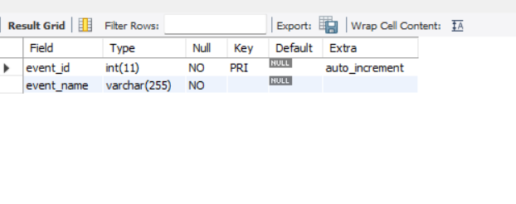

CREATE DATABASE Event_Management;

USE Event_Management;

CREATE TABLE _EVENTS(

event_id INT auto_increment PRIMARY KEY,

event_name VARCHAR(255) NOT NULL

);

DESCRIBE _EVENTS;

CREATE TABLE Attendees(

attendee_id INT AUTO_INCREMENT PRIMARY KEY,

attendee_name VARCHAR(255) NOT NULL

);

DESCRIBE Attendees;

CREATE TABLE Event_attendees(

event_id INT,

attendee_id INT,

FOREIGN KEY (event_id) references _EVENTS(event_id),

FOREIGN KEY (attendee_id) references Attendees(attendee_id)

);

DESCRIBE Event_attendees;

CREATE TABLE event_sponsors(

sponsor_id INT auto_increment PRIMARY KEY,

event_id INT,

sponsor_name VARCHAR (255) NOT NULL,

FOREIGN KEY (event_id) references _EVENTS(event_id)

);

DESCRIBE event_sponsors;